**AN ABSTRACT FOR THE THESIS OF Ann Marie Gawel for the Master of Science in Biology presented June 20, 2012**

**Title: The Ecology of Invasive Ungulates in Limestone Forests of the Mariana Islands**

**Approved: _____________________________________________________________**

**Alexander M. Kerr, Chairperson, Thesis Committee**

Oceanic islands have unique plant communities that have evolved in the absence of large mammals. A variety of animals have been introduced to, and have become established in, these islands since European contact. Many of these introduced animals have left lasting effects on the native flora and fauna of these islands, in some cases, drastically altering ecological systems. The ungulates *Rusa marianna* (Philippine deer) and *Sus scrofa* (pigs) are currently widespread residents of Guam and Rota, oceanic islands in the Mariana Island chain, Micronesia. Although they have been established for centuries, their ecological roles are poorly understood. We investigated the roles of deer and pigs on seedling survival, endozoochorous seed dispersal, and plant community structure in the limestone forests of Guam and Rota. We set up paired fenced and unfenced seedling plots to compare seedling survival of selected limestone forest species. To determine if ungulates selectively dispersed forest plants, we monitored germination in scat. In addition, to see if ungulate abundance affects forest community composition, we used belt transects to characterize forest community composition and to estimate ungulate abundance using scat counts.

Seedling survival was higher for four out of six species in fenced plots compared to unfenced plots for all species on both islands. We recorded germination from both deer and pig scats, with higher rates of germination from pigs. We also found that pigs selectively dispersed native species. Plant community characteristics did not show any clear relationships to pig abundance as estimated by scat counts. Seedling and vine abundance showed strong negative loglinear correlations (R2 ≥ 0.65) to deer abundance in Guam. Plant diversity displayed a quadratic relationship to deer abundance, that is, highest diversity occurred at intermediate levels of deer disturbance. It appears that deer, even at small abundances, are influential in shaping forest community characteristics through herbivory. In contrast, pigs play a larger role in seed dispersal. Hence, even in ecosystems altered by multiple anthropogenic changes, ungulates stand out as major drivers of forest composition. **THE OFFICE OF GRADUATE STUDIES**

**The members of the committee approve the thesis of Ann Marie Gawel presented June 20, 2012**

**___________________________________**

**Alexander M. Kerr, Chairperson**

**___________________________________**

**Ross H. Miller, Member**

**__________________________________**

**Haldre S. Rogers, Member**

**ACCEPTED:**

**______________________________________ ________________**

**John A. Peterson, Ph.D. Date**

**Assistant Vice President**

**Of Graduate Studies,**

**Sponsored Programs and Research**

**THE ECOLOGY OF INVASIVE UNGULATES IN LIMESTONE FORESTS OF THE MARIANA ISLANDS**

**BY**

**ANN MARIE GAWEL**

**A thesis submitted in partial fulfillment of the requirements of the degree of**

**MASTER OF SCIENCE**

**IN**

**BIOLOGY**

**UNIVERSITY OF GUAM**

**JUNE 2012Table of Contents**

1. **Introduction 1**
   1. **Do ungulates affect forest recruitment? 3**
   2. **Do ungulates serve as seed-dispersers? 4**
   3. **How does ungulate abundance relate to forest-community**

**composition? 5**

1. **Methods 7**

**2.1. Study areas 7**

**2.2. Do ungulates affect forest recruitment? 8**

**2.3. Do ungulates serve as seed-dispersers? 12**

**2.4. How does ungulate abundance relate to forest-community**

**composition? 13**

**2.5. Statistical analysis 16**

**2.5.1. Do ungulates affect forest recruitment? 16**

**2.5.2. Do ungulates serve as seed-dispersers? 17 2.5.3. How does ungulate abundance relate to forest-community composition? 18**

1. **Results 20**

**3.1. Do ungulates affect forest recruitment? 20**

**3.2. Do ungulates serve as seed-dispersers? 22**

**3.3. How does ungulate abundance relate to forest-community**

**composition? 25**

1. **Discussion 29**

**4.1. Species-specific effects 29**

**4.2. Overall community composition 30**

**4.3. Comparing Rota to Guam 33**

**4.4. Management recommendations 34**

**Literature Cited 35**

**Appendix 41**

**List of Tables**

**Table 2.1. Species in seedling plots. 10**

**Table 2.2. AIC values for combined species models for seedling plots. 17**

**Table 2.3. Model selection for forest characteristics and deer abundance. 19**

**Table 3.1. Significant effects and interactions in generalized linear mixed**

**models. 20**

**Table 3.2. List and counts of species germinated in scats. 23**

**Table 3.3. Significance for Manly’s Selectivity Index values. 24**

**Table A.1. List of species from Guam vegetation transects. 41**

**Table A.2. List of species from Rota vegetation transects. 43**

**List of Figures**

**Figure 2.1. Seedling plots in Rota (A) and Guam (B). 11**

**Figure 2.2. Design and dimensions of seedling plots. 12**

**Figure 2.3. Transect sites in Rota (A) and Guam (B). 15**

**Figure 2.4. Design and dimensions of vegetation and ungulate-sign transects. 16**

**Figure 3.1. Survival in seedling plots. 21**

**Figure 3.2. Manly Selectivity Indices for native and exotic plants. 24**

**Figure 3.3. Pig and deer abundances in Rota and Guam. 26**

**Figure 3.4. Total seedling abundance versus deer abundance. 26**

**Figure 3.5. Native seedling abundance versus deer abundance. 27**

**Figure 3.6. Exotic seedling abundance versus deer abundance. 27**

**Figure 3.7. Vine abundance versus deer abundance. 28**

**Figure 3.8. Shannon diversity versus deer abundance. 28**

**Acknowledgments**

I would like to thank my parents above all, Michael and Isabel Gawel, who have perhaps made more sacrifices than anyone else to ensure the completion of this project and my degree. I owe many thanks to my committee, comprised of a holothuroid systematist, an entomologist, and an avian ecologist. Their varied interests offered much insight, and their enthusiasm for all types of ecology kept me motivated. Dr. Alexander Kerr, Dr. Ross Miller, and Dr. Haldre Rogers all went above and beyond what one would expect from a thesis committee, and I thank them all very much. I would also like to thank the Ecology of Bird Loss Project for equipment, labor, and a steady stream of friendly biologists, some of who have become my dearest friends. I was fortunate enough to be supported via salary and tuition by the NIH-RISE scholarship, U.S. Fish and Wildlife Service SCEP program, and the Micronesia Challenge Young Champions program. I thank Guam and CNMI’s many agencies and resource managers for advice and access to study sites, especially Dr. Anne Brooke, of Joint Region Marianas, who first taught me about ungulates and their ecological impacts. I would also like to thank my friends at the UOG Marine Lab, College of Natural and Applied Sciences, Poksai canoe team, and Agana Hash House Harriers for their companionship and endless moral support, which kept me sane throughout this process.

**1. Introduction**

Invasive species can be responsible for immense environmental and economic costs, including the decline and even the extinction of native species (Pimentel *et al.* 2005). Their effects are especially pronounced in systems on remote oceanic islands where native species have evolved in isolation, making them less resistant to competitors, predators, and pathogens typical of continental systems (Fritts and Rodda 1998, O’Dowd *et al.* 2003, Leigh *et al.* 2009). Many of these systems have evolved with no mammals besides bats (Bowen and Van Vuren 1997). The past few centuries of human-enabled mammalian introductions to islands provide examples of drastic ecological changes. Predatory mammals such as feral cats are responsible for the extinction of numerous avian populations and species on oceanic islands (Blackburn *et al*. 2004). Herbivores and omnivores such as rabbits, goats, and pigs have also dramatically altering island community structures (Courchamp *et al.* 2003, Weller *et al.* 2010, Spear and Chown 2009). In this study, we investigate the roles of two introduced ungulates, *Sus scrofa* (pigs) and *Rusa marianna* (deer) in the forests of Guam and Rota, two adjacent islands in the Mariana Archipelago.

Introduced ungulates have been of particular concern on islands such as Hawaii and New Caledonia, where they are implicated in the decline of native, especially endemic plant species (Katahira 1980, De Garine-Wichatitsky 2003). By browsing on seedlings and fruits, ungulates can have large impacts on the regeneration of the browsed species, particularly on oceanic islands, where plants have not evolved defenses against large herbivores and frugivores (Ickes *et al.* 2001, Bowen and Van Vuren 1997). Feral pigs can facilitate the spread and establishment of exotic plant species (Aplet *et al.* 1991), fostering displacement of native plant species. Since ungulates have been important historically as game or livestock, feral ungulates frequently become naturalized in new settings (Spear and Chown 2009).

The island of Guam in the Mariana Archipelago, Western Micronesia, is an oceanic island that is no stranger to invasive species. A textbook example of an ecologically detrimental invasive species is the brown treesnake (*Boiga irregularis*), which infamously wiped out native birds in Guam (Savidge 1987). The disappearance of birds has undoubtedly altered the island’s ecosystems, but snakes are not the only introduced creatures affecting the ecosystems of Guam. Feral pigs have been present on the island since the 17th century (Conry 1989), and the Philippine deer (*R. marianna*) was introduced in the 18th century (Safford 1905). As on many other oceanic islands, the native species of Guam have evolved in the absence of large mammals. These introduced ungulates are believed to play significant roles in altering the plant communities on the island, especially in areas with large populations of both species (Conry 1989, Schreiner 1997, Wiles *et al*. 1999).

The forests of Guam share many of the species and characteristics of the forests in other islands of the Mariana Archipelago. However, several key differences have caused their ecosystems to diverge in recent history. Most notably, the extirpation of forest birds has eliminated most of the island’s native seed dispersers (Fritts and Rodda 1998). The islands of Guam and Rota present a unique opportunity to study the roles of two introduced, but naturalized ungulates and their ecological roles in changing ecosystems. The forests of Guam are absent of birds and can harbor large numbers of deer and pigs (Wiles *et al*. 1999, Perry and Morton 1999). The forests of Rota are historically similar to Guam, harbor populations of deer and pigs, but are still home to native populations of forest birds (Wiles *et al*. 1999).

The largest impacts from ungulates will likely happen in ecosystems where they perform a novel function, such as in insular systems with evolutionary naïveté to large herbivores (Spear and Chown 2009). Because of the absence of large mammalian herbivores during the evolution of Guam’s and Rota’s ecosystems, deer and pigs seem to have created novel ecological roles for themselves during their centuries of habitation in these islands. Since their introduction to Guam, deer and pigs are known to have played roles in shaping the ecosystems they inhabit through herbivory and physical disruption of the forest floor (Conry 1989, Wheeler 1979, Schreiner 1997, Wiles *et al.* 1999). However, many questions remain about what exactly these roles are, especially what they are now, in the currently disturbed and bird-free forests of Guam. Hence, in this study, the following questions are specifically addressed:

* Do ungulates affect forest recruitment?
* Do ungulates serve as seed-dispersers?
* How does ungulate abundance relate to forest-community composition?

*1.1 Do ungulates affect forest recruitment?*

Ungulates are believed to affect recruitment of native trees in Guam (Schreiner 1997). Deer in Guam are believed to have a great effect on regeneration of preferred species (Schreiner 1997, Wiles *et al.* 1999). However, little work has been done to determine which species are palatable or if certain groups of plants, such as native seedlings or ferns, are more affected by ungulate presence. Effects on seedling survival and plant community dynamics have been documented in a number of other habitats with known cervid populations. In Japan, Sika deer (*Cervus nippon*) browse on seedlings and saplings, suppressing forest regeneration (Takatsuki 2009). In North America, decreased seedling height and abundance were observed across multiple hardwood species with increasing abundance of white-tailed deer (*Odocoileus virginianus*) (Horsley *et al.* 2003). Enclosure and population studies in the Midwestern United States showed that population densities of white-tailed deer (*O.virginianus*) as low as 4 deer/km2 can prevent regeneration in once common tree species such as eastern hemlock (*Tsuga canadensis*) and white cedar (*Thuja occidentalis*) (Alverson *et al.* 1988, Rooney & Waller 2003). A study conducted in northern Guam estimated *R. marianna* population density to be 183 ± 39 deer/km2 (Knutson and Vogt 2002).

Feral pigs (*S. scrofa*) have an almost global distribution (Dewey and Hruby 2002). They are known to affect regeneration and recruitment in a number of forest systems. For example, feral pigs have a pronounced effect on regeneration in lowland forests of Malaysia, by direct predation on seeds and by soil-rooting (Ickes *et al.* 2001). Rooting kills or physically damages seedlings and can alter soil properties (Singer *et al.* 1984, Ickes *et al.* 2001). Pigs are seen as a major threat to native biodiversity in Hawaii, where exclosure studies have shown marked increases in forest recruitment and seedling abundance (Loh and Tunison 1999, Weller *et al.* 2010) when pigs were eliminated from the areas. The deer population study from Guam mentioned above also estimated *S. scrofa* population density at 38 ± 18 pigs/km2 (Knutson and Vogt 2002).

*1.2 Do ungulates act as seed-dispersers?*

Aside from grazing, deer can potentially affect species composition by dispersing species of palatable fruits or seeds that get consumed accidentally from plants with preferred foliage (Janzen 1984, Myers *et al*. 2004, Vickery *et al*. 1986). However, usually only small and hardy seeds that can survive both mastication and digestion are likely to be dispersed (Gill and Beardall 2001). Feral pigs are also known to act as agents of seed dispersal. In Hawaii, they are believed to facilitate plant invasions (Aplet 1991, Weller *et al.* 2010), having been observed to feed preferentially on certain alien species there (Stone 1985). The role of ungulates as seed dispersers is of particular importance in Guam, which, with the disappearance of forest birds, has lost its native seed dispersers.

*1.3 How does ungulate abundance relate to forest-community composition?*

As evident by the examples above, ungulates are capable of playing a major role in shaping the composition of an ecosystem. Areas with high abundances of ungulates exhibit specific characteristics: an abundance of some species, a decrease or lack of other species, a decrease in seedlings, especially in seedlings of preferred browse species, and sometimes a depleted understory. The presence of some plants may be enhanced by deer or by pigs; this could be due to decreased competition with plants that are eaten (Aplet *et al.* 1991, Loh and Tunison 1999). Ungulates may also change ecosystem characteristics such as soil composition and light penetration, which could have varied effects across a range of plant species. (Cabin *et al.* 2000, Coté *et al.* 2004, Nogueira-Filho *et al.* 2009). Additionally, certain plants may prosper through increased dispersal by ungulates (Pakeman *et al.* 2002, Nogueira-Filho *et al.* 2009). Ungulates are also associated with altered forest conditions such as lower biodiversity (Vásquez and Simberloff 2003, Stockton *et al.* 2005, Spear and Chown 2009) and shifts in size classes or types of vegetation (Veblen *et al.* 1989, Russel *et al.* 2003).

**2. Materials and Methods**

*2.1 Study Area*

Guam (13.45° N, 144.78° E; 540 km2) is the largest and southernmost island of the Mariana Island Archipelago in the Western Pacific. Rota (14.15° N, 145.21° E; 85 km2) is located 76 km north of Guam and has less than 2% of the population of Guam. Both islands have large areas of native limestone forest with similar species compositions. Although deer and pigs are found in other habitats, limestone forests were chosen as the habitats of focus in this study because they contain a larger variety of native and endemic tree species relative to other habitats, such as savannah or ravine forest (Fosberg 1960, Raulerson and Rinehart 1991). According to the most recent forest inventory, Guam’s landcover is 48% forested, 33% grass and shrublands, <1% barren, and 18% urban or developed (Donnegan *et al*. 2002). Most limestone forest communities in Guam consist of mixtures of native and secondary species types (Donnegan *et al*. 2002).

The forests of Rota are perhaps the most undisturbed examples of these habitats in the Marianas, and they contain many of the same plant species found in Guam (NPS 2005). Rota’s forests still harbor larger populations of the federally protected *Serianthes nelsonii* and *Osmoxylon mariannense* (NPS 2005). Rota’s forests are also home to 10 native bird species and the Marianas fruit bat (*Pteropus mariannus*). Communication with natural resource managers suggested that feral pig populations were absent in Rota. However, scat surveys indicated varied population densities of pigs across limestone forest sites in Rota.

*2.2 Do ungulates affect forest recruitment?*

This portion of the project was conducted in conjunction with the Ecology of Bird Loss (EBL) research team. Principal investigators were Dr. Joshua Tewksbury and Dr. Janneke Hille Ris Lambers, Department of Biology, University of Washington, and Dr. Ross Miller, College of Natural and Applied Sciences, University of Guam. The EBL team is studying the effects of avifauna loss on the forest ecosystems of the Marianas. Chicken-wire fences were erected in multiple forest sites to protect seedling plots from ungulate damage. This provided an opportunity to study ungulate effects on seedlings by duplicating the seedling plots in an adjacent location without fencing, allowing ungulate access. Eight sites were selected in limestone forests in northern Guam and seven sites in limestone forests in Rota (Figure 2.1). All sites have resident deer and pig populations. Plot placement was selected with an effort to minimize differences in substrate, vegetation types, and canopy cover among the treatments.

At each site, we erected an ungulate exclosure that fenced an area 3.5 m x 5.5 m with 1.8-m-tall chicken wire (Figure 2.2). The EBL team has used these methods to successfully keep deer out of similar-sized areas in limestone forest for the previous two years (Haldre Rogers, Rice University, 2009 *pers.comm.*). The fenced plots were duplicated nearby, in an unfenced area of the same size, allowing ungulate access (Figure 2.2).

Six species were used in this experiment (Table 2.1), encompassing a variety of native and introduced trees found in limestone forests of the Mariana Islands: *Carica papaya*, *Morinda citrifolia*, *Neisosperma oppositifolia*, *Aglaia mariannensis*, *Premna obtusifolia*, and *Psychotria mariannensis*. All are common members of limestone forest communities in Guam and Rota.Because fruiting periods vary and because it was easier for collectors to focus on one or two species at a time, the collection of fruits, germination, and out-planting were staggered through the year (see Table 2.1). For each species, seeds were collected from at least five trees and at least four different sites to minimize maternal effects and effects of local adaptation. All seeds were planted on the island from which they were collected.

After seeds were collected, they were cleaned and prepared for planting, and then planted under shadecloth at a nursery in Guam and at a nursery in Rota. Seeds were planted in seedling trays in a mixture of 50% perlite and 50% peat moss, and fertilized using Osmocote®. They were watered almost daily, depending on need. The seedlings were transported to the exclosure sites after they had grown their first true leaves, and after they had fully rooted.

For each site, all seedlings were planted in the control and treatment areas on the same day. They were planted at least 0.3 m apart from each other, and at least 0.5 m away from the fences in fenced treatments (Figure 2.2). Seven seedlings of *N. oppositifolia* and 14 seedlings of the other five species were planted in each treatment at each site, a total of 1232 seedlings in Guam. In Rota, nine seedlings of *N. oppositifolia*, 11 seedlings of *C. papaya*, and 14 seedlings of the other four species were planted in each treatment at each site, a total of 1190 seedlings. The seedlings planted during drier months (*C. papaya, M. citrifolia,* and *N. oppositifolia*) were watered regularly during the first few weeks after transplantation. After transplanting, seedlings were monitored monthly for mortality. Any evidence of ungulate-caused damage or mortality was recorded. It was also noted whether seedlings appeared clipped, dug up, or whether mortality did not seem to be caused by ungulates.

**Table 2.1.** Species in seedling plots.

|  |  |  |  |  |  |  |
| --- | --- | --- | --- | --- | --- | --- |
| **Species** | **Planting month** | **N per plot Guam** | **N per plot Rota** | **Native/ Introduced** | **Documented as food item** | |
| **Deer** | **Pigs** |
| *Carica papaya* | Apr 10 | 14 | 11 | Introduced | seeds, fruit (MW) | fruits (PC) |
| *Morinda citrifolia* | Jul 10 | 14 | 14 | Native |  | fruits (PC) |
| *Neisosp. oppositifolia* | Jun 10 | 7 | 9 | Native |  |  |
| *Premna obtusifolia* | Dec 10 | 14 | 14 | Native | seeds, foliage(MW) | fruits (PC) |
| *Aglaia mariannensis* | Nov 10 | 14 | 14 | Endemic to Marianas | not a preferred species (GW) |  |
| *Psych. mariannensis* | Mar 11 | 14 | 14 | Endemic to Marianas |  |  |

**GW:** Wiles et al 1999; **MW:** Wheeler 1979; **PC:** Conry 1989

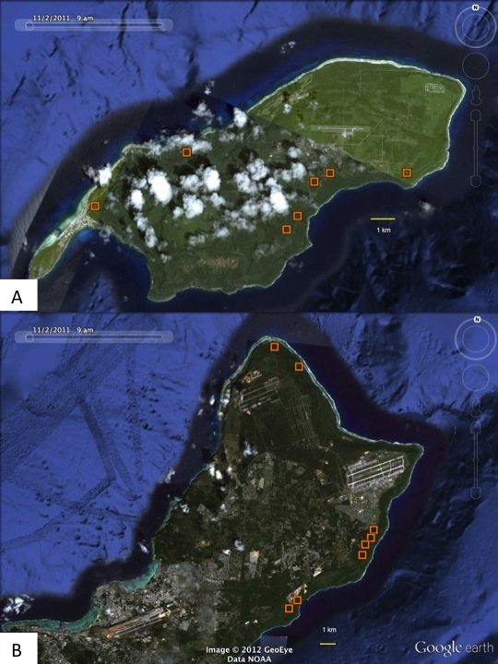

**Figure 2.1.** Seedling plots in Rota (A) and Guam (B). Plots, in orange, are in limestone forests.

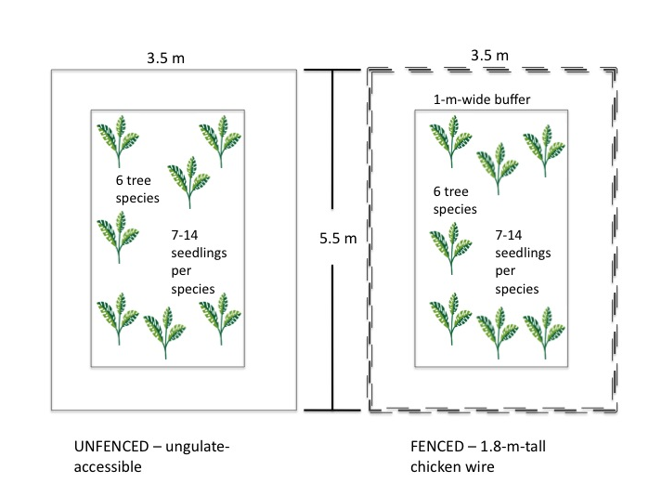

**Figure 2.2.** Design and dimensions of seedling plots.Seedlings of six different species of trees were planted in paired plots. Paired plots are not necessarily next to one another, but within 10 m of each other.

*2.3 Do ungulates act as seed-dispersers?*

We collected scats from *R. marianna* and *S. scrofa* from several limestone forest sites to determine if either ungulate dispersed viable seeds via endozoochory. Location and date were recorded for each collection. We collected throughout the year from four different sites.

We dried the scats for one to two days in a drying oven and recorded their dry weights. After drying, scat samples were layered on top of a 50% perlite and 50% peat moss soil mix in germination trays. The trays were outdoors at a nursery, under shadecloth. *R. marianna* pellets were mixed in at the surface, and *S. scrofa* scats were broken up to mix at the surface. Trays were watered regularly before and after any seedlings emerged from scats. Seedlings were then identified and counted.

*2.4 How does ungulate abundance relate to forest community composition?*

Vegetation surveys were conducted to gather community composition data about limestone forest sites across Guam and Rota (Figure 2.3). We surveyed vegetation using two 50-m by 1-m transects (see Figure 2.4), covering a total of 100 m2. At sites with exclosures, transects ran from opposite corners of the exclosure. At sites without exclosures, they were placed end to end. All plants within these belt transects were identified and recorded. Height was approximated for each adult plant, seedlings were identified and counted, epiphytes were identified on adult plants, and plants were categorized as vines, trees, ferns, or herbs.

In addition to vegetation surveys, scats from both *S. scrofa* and *R. marianna* were counted to estimate relative abundance for each across the sites. After surveys at the initial sites, seven additional sites in Guam were added to increase variation in ungulate abundance, as well as to cover more limestone forest area after gaining access to Andersen Air Force Base, which has extensive limestone forest habitat. One exclosure site, Racetrack Fragment, was excluded, as it did not provide enough forest area to run 100 m2 of transect line. A total of 14 sites were surveyed in Guam.

Because animal tracks are almost impossible to see in limestone forest terrain, and the detectability of other sign such as trails and grazing vary widely even in similar habitats, we determined scat to be the most reliable indicator of ungulateabundance (Schreiner 1997). Scats from *S. scrofa* and *R. marianna* were counted along the vegetation transects. To boost scat sample size, a GPS device was used to walk roughly 400 meters in a square around the vegetation transect area (see Figure 2.4.), and scats were identified to ungulate species and counted in a 2-meter belt. Other types of sign such as tracks, rooting, herbivory, antlers, actual remains, and sightings of the animals themselves were noted as well.

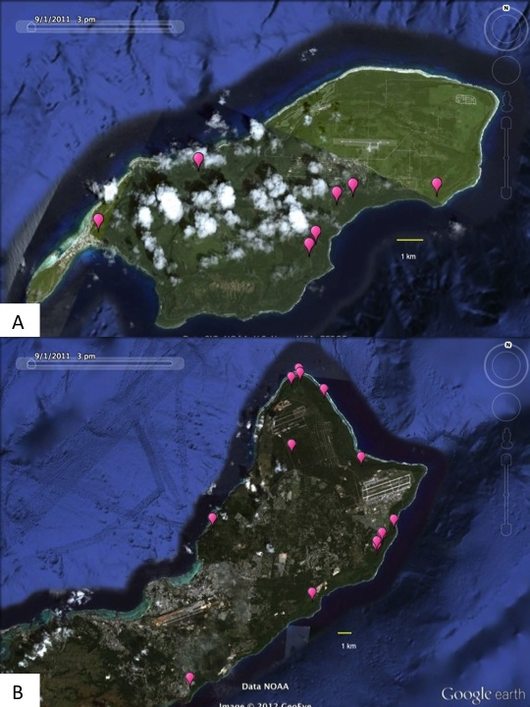**Figure 2.3.** Transect sites in Rota (A) and Guam (B). Sites, in pink, were in limestone forests.

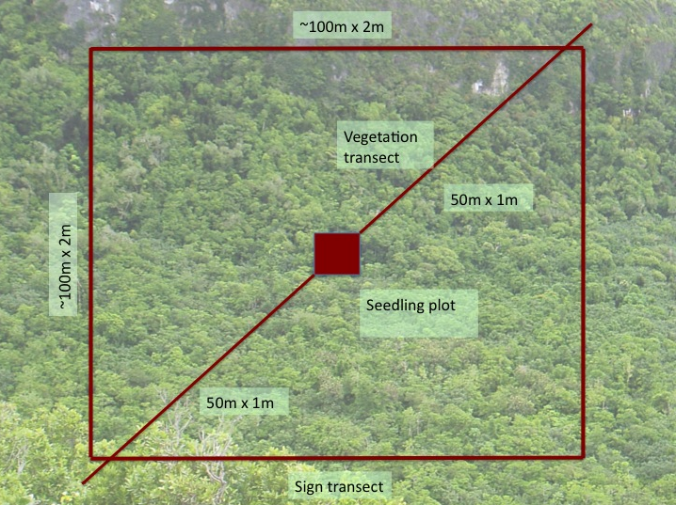

**Figure 2.4.** Design and dimensions of vegetation and ungulate-sign transects. Two 50-m by 1-m transects were used to survey vegetation. Scats and other ungulate sign were counted along these transects and additional walking transects, in approximately a 100-m by 100-m square. The opaque square in the center depicts the seedling-plot exclosure that was present at most, but not all, of the sites.

*2.5 Statistical analyses*

*2.5.1. Do ungulates affect forest recruitment?*

Seedling survival was compared between fenced and unfenced plots, for each species planted. This was done using generalized linear models with mixed effects in R statistical software (R Development Core Team 2011). In these linear models, the fixed effects were fencing, species, and island, and site was a random effect. Factors were sequentially removed to determine their importance to giving the simplest fitted model. We determined that species had a strong effect on survival, and that it interacted with fencing to affect survival (Table 2.2). Therefore, we analyzed species separately with island and fencing treatment as fixed effects and site as a random effect. Factors were considered to have a significant effect on seedling survival if they improved AIC scores by more than -2 (Burnham and Anderson 2004) when included in a linear model.

**Table 2.2**. AIC values for combined species models for seedling plots. Species, and the interaction between species and treatment, improved AIC scores significantly (by > 2). Removing them increased AIC scores, indicated by ∆AIC.

|  |  |  |  |  |  |
| --- | --- | --- | --- | --- | --- |
| **Fixed Effects** | **Interactions** | **Factor removed** | **df** | **AIC** | **∆AIC** |
| species, island, fencing | species x fencing, island x fencing | None | 15 | 776.7 |  |
| species, island, fencing | island x fencing | species x fencing | 10 | 790.9 | 14.3 |
| island, fencing | island x fencing | species, species x fencing | 5 | 1072.7 | 296.0 |

*2.5.2* *Do ungulates act as seed-dispersers?*

The identity and abundance of all species that germinated from scats are presented in Table 3.2. Analysis focused on germination from pig scats, which had significantly more frequent germination when compared to deer scats. This was determined using a binomial test in R statistical software (R Core Development Team 2011). Selectivity was estimated using indices prescribed in Manly *et al.* (1993). This was done using the abundances of species that germinated from scat compared to their abundances in nature represented by data from vegetation surveys.

To determine if pigs exhibited selectivity for either native or exotic species that germinated from scat, we collected scat from two sites and compared them to vegetation surveys from those same sites. Although scat was collected from other sites, the majority of them were found from two sites, and the higher number of scats provided a more reliable basis for preference analysis. The two sites were Ritidian Gate on the National Wildlife Refuge, and Anao North in the Anao Conservation Area. We calculated the Manly Selectivity Index (Manly *et al.* 1993) for native and for exotic species at each site

*B = wi / ∑ wj*,

where *wi* is the selection probability determined by

*wi = ui / πi,*

where *u*i is the proportion of seedlings from scat of either native or exotic seedlings amongst all seedlings from scats from that site, and *πi* is the proportion of native or exotic adult plants at the site. Because nearly all ferns disperse their spores by wind (Tryon 1970), they were excluded from this analysis. Upper and lower confidence intervals for *wi* were calculated by using

*se(wi) =1.96 √{(1 - πi) / (utotπi)}.*

*2.5.3.* *How does ungulate abundance relate to forest community composition?*

We could not combine pig and deer abundance because sign counts are not comparable due to potentially different and unknown rates of defecation and decomposition. Therefore, we used deer abundance and pig abundance as separate independent factors and forest characteristics as dependent factors. The forest characteristics that we investigated were total seedling abundance, native seedling abundance, exotic seedling abundance, vine abundance, and Shannon diversity (Shannon 1948). We tested for outliers using Bonferroni outlier tests. P-values for studentized residuals less than 0.05 would be considered outliers. The most extreme values all had Bonferroni P-values greater than 0.05, and so all data were included in analyses. R2 and P-values for each regression were determined using linear models in. To select the best fit linear models, F-statistics and P-values were also calculated (see Table 2.3). All calculations and tests were performed using R statistical software (R Core Development Team 2011).

**Table 2.3.** Model selection for forest characteristics and deer abundance. F-statistic, R2, and P-values used in selecting the best fit for each deer-abundance-to-forest-characteristic relationship.

|  |  |  |  |  |
| --- | --- | --- | --- | --- |
| **Model type** | **Dependent variable (y)** | ***R2*** | ***F*** | ***P*** |
| linear | total seedlings | 0.337 | 6.089 | 0.030 |
| loglinear* | total seedlings | 0.710 | 29.350 | < 0.001 |
| linear | native seedlings | 0.338 | 6.122 | 0.293 |
| loglinear* | native seedlings | 0.648 | 22.070 | < 0.001 |
| linear | exotic seedlings | 0.172 | 2.499 | 0.140 |
| loglinear* | exotic seedlings | 0.770 | 40.060 | < 0.001 |
| linear | vines | 0.316 | 5.55 | 0.036 |
| loglinear* | vines | 0.751 | 36.160 | < 0.001 |
| linear | Shannon | 0.070 | 0.909 | 0.359 |
| quadratic* | Shannon | 0.516 | 5.852 | 0.019 |
| cubic | Shannon | 0.601 | 5.030 | 0.022 |
| * indicates the preferred model presented in results | | | | |

**3. Results**

*3.1 Do ungulates affect forest recruitment?*

Seedling survival in seedling plots varied depending on species, island where they were planted, and fencing treatment. Treatment effects, or exposure to ungulates by planting in unfenced plots, decreased seedling survival significantly in four out of the six species planted (Table 3.2, Figure 5). Survival was significantly lower in unfenced or ungulate-accessible plots for *C. papaya*, *M. citrifolia*, *P. obtusifolia*, and *P. mariannensis*. Treatment had no significant effect on *A. mariannensis* or *N. oppositifolia*. Treatment and island had a significant interaction for *A. mariannensis*, although there was no difference between treatments for this species. Treatment and island also had a significant interaction for *P. mariannensis*, which had lower survival in ungulate plots in Guam, but no difference between treatment plots in Rota.

**Table 3.1.** Significant effects and interactions in generalized linear mixed models. Fixed effects significantly affecting survival, as indicated by AIC values of linear mixed models, are listed with ∆AIC when that effect was removed from the model.

|  |  |  |
| --- | --- | --- |
| **Species** | **Significant Effects** | **∆AIC** |
| *Aglaia mariannensis* | island | 2.99 |
|  | island x fencing | 3.36 |
| *Carica papaya* | fencing | 47.70 |
| *Morinda citrifolia* | fencing | 11.20 |
|  | island | 3.40 |
| *Neisosperma oppositifolia* | island | 6.63 |
| *Premna obtusifolia* | fencing | 12.71 |
| *Psychotria mariannensis* | fencing | 22.10 |
|  | island | 14.14 |
|  | island x fencing | 16.08 |

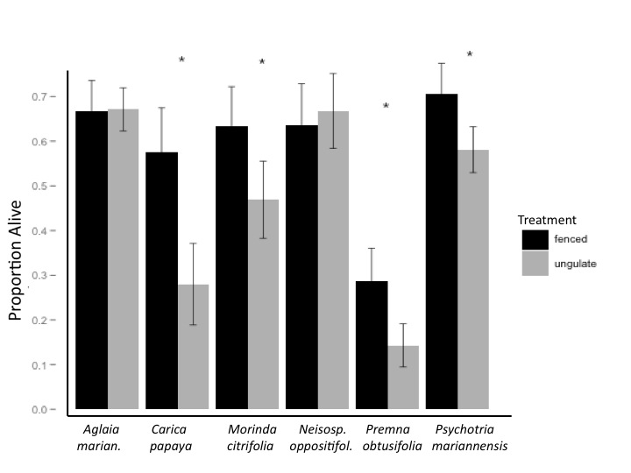

**Figure 3.1.** Survival in seedling plots.Treatment by fencing or removing ungulate access affected seedling survival, indicated by “proportion alive.” Error bars show one standard error of the mean. * indicates treatment had a significant effect on seedling survival based on ∆AIC when treatment was added to the linear model.

*3.2 Do ungulates act as seed-dispersers?*

We collected a total of 20 deer scats (pellet groups) and 31 pig scats from a number of limestone forest sites. Because very few seedlings emerged from the deer scats, analysis was focused on pig scats, and germination from deer scats is thus only briefly described here. Only four of the 20 deer scats collected had seedlings that appeared to have germinated after endozoochory. One scat had eight *C. papaya* seedlings and one scat had one *Passiflora suberosa* seedling. The other species that germinated were and one *Vitex parviflora*, and one *Mikania micrantha*, whose seed may have blown into the seedling tray (ISSG 2012). Alternatively, the seed could have been ingested accidentally, as this species does not have an edible fruit.

A greater abundance and diversity of seedlings emerged from collected pig scats. To determine if germination was significantly different between pig and deer scats, a binomial test was run between the total number of seedlings (11) from the 20 deer scats and the total number of seedlings (802) from 20 randomly selected pig scats. P < 0.001 for k = 11 successes.

Of the 31 pig scats collected from four different sites, 25 scats had seedlings (80.6%), with a total of 1657 seedlings successfully germinating. The species that germinated from pig scats were the native trees *M. citrifolia*, and *Ficus prolixa,* the introduced trees *C. papaya* and *Leucaena leucocephala*,and the introduced vines *Passiflora* spp.*, Chromolaena odorata* and *Coccinia grandis* (Table 3.2). All of these except for *C. odorata* and *L. leucocephala* have edible, fleshy fruits.

In this analysis, the stark differences in selectivity *B* between native and exotic species for both sites (Figure 3.2), and high significance (Table 3.3) indicate strong selection for native species dispersal. This should not be interpreted as an actual dietary preference that the pigs themselves have, but the result of a combination of factors that include the pigs’ dietary preferences, the abundance of seeds per fruit and fruit per tree, and the likelihood of survival after being digested. Considering all of this, the *w* and *B* values strongly indicate selection for native species at both sites (Table 3.3). All have fleshy and abundant fruits on each tree, and both *M. citrifolia* and *C. papaya* have large numbers of seeds per fruit.

**Table 3.2.** List and counts of species germinated in scats.A variety of species germinated from deer (n = 20) and pig scats (n = 31).

|  |  |  |  |  |
| --- | --- | --- | --- | --- |
|  | **Deer** |  | **Pig** |  |
| **Species** | **N seedlings** | **N scats** | **N seedlings** | **N scats** |
| *Morinda citrifolia* | 0 | 0 | 1041 | 20 |
| *Carica papaya* | 8 | 1 | 262 | 13 |
| *Vitex parviflora* | 1 | 1 | 0 | 0 |
| *Passiflora suberosa* | 1 | 1 | 13 | 3 |
| *Mikania micrantha* | 1 | 1 | 0 | 0 |
| *Coccinia grandis* | 0 | 0 | 4 | 3 |
| *Chromolaena odorata* | 0 | 0 | 1 | 1 |
| *Ficus prolixa* | 0 | 0 | 247 | 3 |
| *Leucaena leucocephala* | 0 | 0 | 1 | 1 |
| Total | 11 | 4 | 1569 | 25 |

**Table 3.3.** Significance for Manly Selectivity Index values. Significant *χ2* values indicated selection occurred for seedlings from pig scats.

|  |  |  |  |  |  |  |  |
| --- | --- | --- | --- | --- | --- | --- | --- |
| **Site** | **Native / Exotic** | **n nature** | **prop. nature** | **n scat** | **prop. scat** | **χ2** | **P** |
| Anao North | exotic | 23 | 0.225 | 7 | 0.015 | 114.719 | <0.001 |
| Anao North | native | 79 | 0.775 | 447 | 0.980 |  |  |
| Ritd. Gate | exotic | 37 | 0.607 | 272 | 0.244 | 611.749 | <0.001 |
| Ritd. Gate | native | 24 | 0.393 | 841 | 0.756 |  |  |

**Figure 3.2.** Manly Selectivity Index values (*B*) for native and exotic plants. Manly Selectivity Index values were higher for native species in pig scats collected from Anao North and Ritidian Gate. Error bars represent 95% CI calculated for *B*.

*3.3. How does ungulate abundance relate to forest community composition?*

We used scat counts for deer and pigs to estimate relative abundance amongst sites. Deer scat counts varied greatly between the fourteen sites surveyed in Guam, indicating a wide variation in deer abundance between the sites. Deer scat counts in Rota varied less amongst the seven sites surveyed, all of which had scat counts smaller than the maximum value in Guam (Figure 3.3).

Strong negative loglinear relationships were detected between the following forest characteristics and deer abundance: total seedling abundance (R2 = 0.710, P < 0.001), native seedling abundance (R2 = 0.648, P < 0.001), exotic seedling abundance (R2 = 0.770, P < 0.001), and vine abundance (R2 = 0.751, P <0.001). No associations were detected between these community characteristics and deer abundance in Rota, and no associations were detected between these characteristics and pig abundance. Shannon diversity *H’* had a significant quadratic relationship with deer abundance only in Guam (R2 = 0.516, P = 0.019) (Figure 3.7). There were no significant associations between pig abundance and plant diversity in either Guam or Rota.

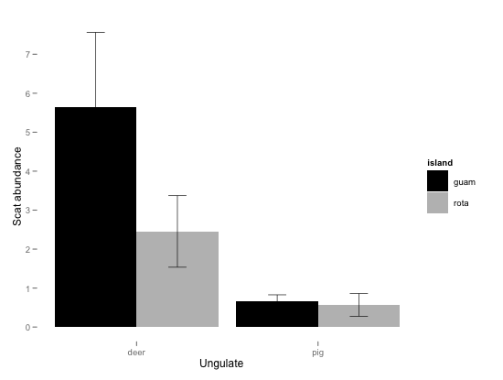

**Figure 3.3**. Pig and deer abundances in Rota and Guam.

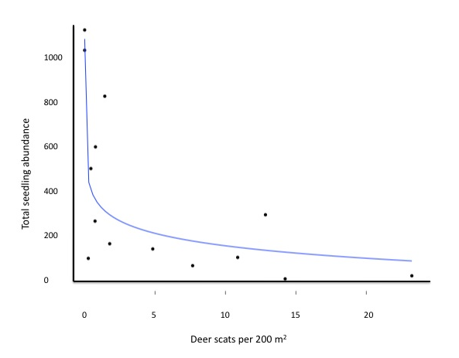

**Figure 3.4.** Total seedling abundance versus deer abundance.Total seedling abundance has a strong negative loglinear correlation to deer abundance across the sites in Guam (y = -76.24 ln(x) +373.86, R2 = 0.710, P < 0.001).

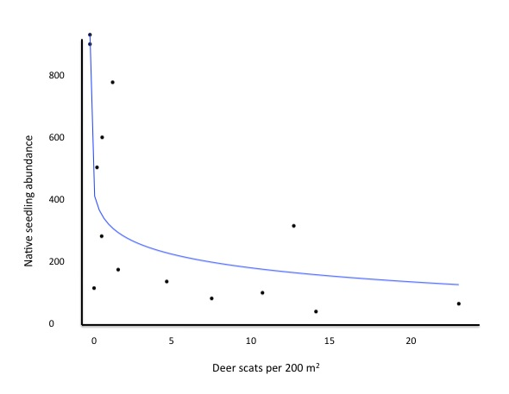

**Figure 3.5.** Native seedling abundance versus deer abundance. Native seedling abundance had a strong negative loglinear correlation to deer abundance across sites in Guam (y = -63.98 ln(x) +331.99, R2 = 0.648, P < 0.001).

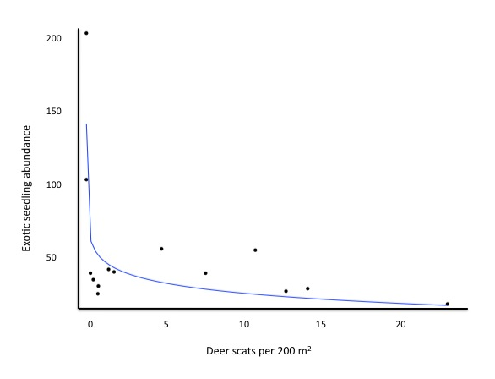

**Figure 3.6**. Exotic seedling abundance versus deer abundance. Exotic seedling abundance had a strong negative loglinear correlation to deer abundance across sites in Guam (y = -12.41ln(x) +38.87, R2 = 0.770, P < 0.001).

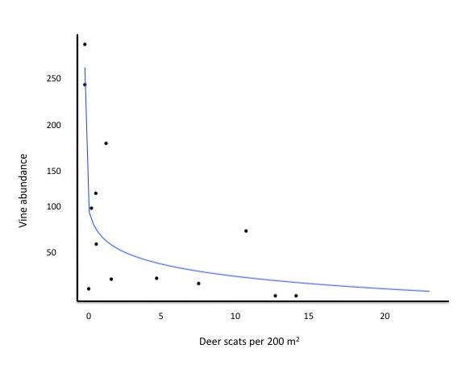

**Figure 3.7.** Vine abundance versus deer abundance.Vine abundance had a strong negative loglinear correlation to deer abundance across sites in Guam (y = -20.68 ln(x) + 79.20, R2 = 0.751, P < 0.001).

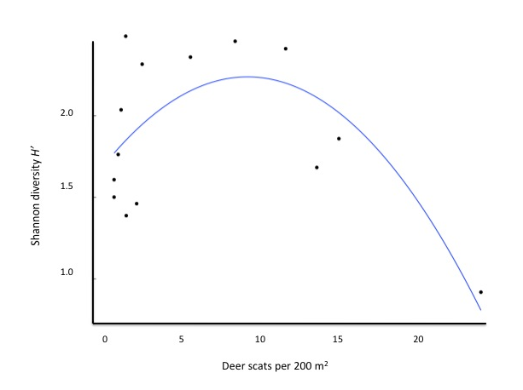

**Figure 3.8.** Shannon diversity versus deer abundance.Shannon diversity had a quadratic relationship with deer abundance in Guam (y = -0.007x2 + 0.036x + 0.312, R2 = 0.516, P = 0.019).

**4. Discussion**

*4.1 Species-specific effects*

The effects of deer and pigs on limestone forest plants are largely species-specific. Seedling plot experiments showed that survival varied from species to species when seedlings were exposed to ungulates. Pigs and deer affect species in different ways, and the responses in our study strongly suggest that deer herbivory was responsible for the seedling mortality. Deer species in other parts of the world seem to show strong selection for certain species when browsing (Horsley *et al.* 2003, Takatsuki 2009). In contrast, pigs are documented to affect seedlings by rooting or physically disturbing the soil, which is less discriminate in affecting seedling species (Ickes *et al.* 2001). Because rooting was observed at only a few of our sites, with only a few individuals uprooted, it is very likely that deer were responsible for much of the seedling mortality at the sites. Combined with evidence from vegetation surveys that showed strong decreases in overall seedling abundance with increasing deer abundance, this suggests that deer are capable of playing a large role in determining species composition of forests. Studies on white-tailed deer (*O. virginianus*) in North America have shown similar patterns where non-preferred species began to dominate ecosystems where deer were abundant (Horsley *et al.* 2003).

Pigs are capable of endozoochorous dispersal of a variety of plants with a selection for native species. In Hawaiian studies, feral pigs were associated with invasive plant assemblages because they preferentially dispersed invasive over native species, and because their rooting activities created disturbed patches that facilitated invasion by weedy species rather than recolonization by native species (Aplet *et al.* 1991). Other species of ungulates have also been implicated in preferentially dispersing exotic over native species (Pakeman *et al.* 2002, Vavra *et al*. 2007). However, in our study, pigs scats contained significantly higher numbers of germinable seeds from native plants. Therefore, seed dispersal by pigs in Guam contrasts with seed dispersal by introduced ungulates in many other areas of the world.

Pigs are dispersing some native species formerly dispersed by birds. *M. citrifolia* and *F. prolixa* are native species that were both present in high numbers in pig scats and are known to be dispersed by birds in island ecosystems (Stone 1970, Whitaker and Jones 1994). However, pigs are by no means ecological substitutes for birds. Birds effectively disperse *Ficus* spp. in the Marianas by dropping them on trees, where they grow by extending their roots to the ground and growing over the host tree (Fosberg 1960), while pigs deposit *F. prolixa* seeds on the ground. This still leaves a large number of historically bird-dispersed species without any known dispersers. Thus, pigs are dispersing a number of avian-dispersed species in Guam, but are not fulfilling these empty ecological niches left without birds.

*4.2 Overall community composition*

Vegetation surveys showed that a small initial increase in deer abundance drastically reduced seedling abundance (Figure 3.3). This suggests that limited hunting or culling would have nearly no effect on vegetation recovery. For example, a study on introduced red deer (*Cervus elaphus*) in New Zealand showed limited vegetation recovery even after four decades of ungulate control and low densities of deer (Tanentzap *et al.* 2009). Our study suggests a reason for this. The negative exponential relationships we found between forest characteristics and deer abundance (Figure 3.3) demonstrates that forests are heavily damaged, and about equally so, across all, except extremely low, deer abundances. Therefore, only drastic reductions or elimination of deer would lead to noticeable recovery of forest communities.

Deer do not have any clear preference for exotic over native seedlings. In Guam, we found that a small initial increase in deer abundance led to sharp declines in both native and exotic seedlings (Figures 3.3 and 3.4). These results contrast with other studies that suggest that introduced ungulates preferentially control invasive plant species. For example, in New Zealand when culling reduced deer to low numbers, invasive species inhibited the recovery of native species (Coomes *et al.* 2003,). Similarly, in Hawaii, invasive species dominated when ungulates were eradicated from areas (Weller *et al.* 2010). Further, our study shows that at zero deer abundance, there is an estimated order of magnitude more native than exotic seedlings (375 native versus 39 exotic), and a higher species richness of native seedlings (20 native versus 15 exotic). Hence, while the number of exotic seedlings may increase after ungulate control in the Marianas, native species will increase proportionally more.

Deer also had important effects on overall forest community diversity. We saw a quadratic relationship between plant diversity and deer abundance (Figure 3.7). Forest diversity was highest at intermediate levels of deer abundance. This pattern of plant diversity is consistent with the intermediate disturbance hypothesis (IDH) (Connell 1978). IDH proposes that at low levels of disturbance, such as from herbivory, a few competitive dominants rule, while at high levels of disturbance, only disturbance-tolerant species survive. In contrast to our results, many studies about ungulate effects on biodiversity show a pattern of monotonic decline (Stockton *et al.* 2005, Spear and Chown 2009). In fact, a review by Milchunas *et al.* (1988) concluded that grazing as a disturbance often failed to support IDH because of concomitant changes in modes of competition among plant species with increasing disturbance. One of the few studies of herbivory that did support the IDH model involved deer, and was restricted to ground-cover in a temperate forest habitat. However, the pattern was only evident when other environmental factors were controlled (Suzuki *et al.* 2012). Our study, in contrast, showed an IDH pattern in forest community diversity as a response to deer herbivory, even with other environmental factors at play.

Deer may contribute to maintaining forest gaps. Our exclusion study showed that the gap pioneers *C. papaya* and *M. citrifolia* (Fosberg 1960) suffered significantly higher mortality than the late successional species *N. oppositifolia* and *A. mariannensis* (Figure 3.1). In addition, vines, which are also important gap pioneers, significantly decreased with increasing deer herbivory (Figure 3.6). Guam, which has the highest densities of deer in the Marianas, has larger and more numerous gaps than other Mariana Islands (H. Rogers *et al.,unpubl.*). These results suggest that deer limit primary succession of gap pioneers, resulting in forests with more gaps, higher light penetration, and greater air movement, all factors known to control the abundances and distribution of other forest organisms (Brokaw and Scheiner 1989).

*4.3 Variation between islands*

Forests of the two adjacent islands had different responses to ungulate herbivory. Unlike in Guam, we did not observe any association between seedling abundance and deer abundance in Rota. The continued presence of avian seed dispersal in Rota may have obscured any associations between seedling abundance and deer abundance there. Other studies have observed complimentary roles of herbivory and seed dispersal in (Henry and Dubost 1999, Vellend et al. 2006), but focus on one species responsible for both herbivory and dispersal. We speculate that multiple species may be determining forest composition through a combination of herbivory and seed dispersal.

Other inter-island differences were equally difficult to explain. Seedling mortality was higher in Rota for both fenced and unfenced treatments (Figure 3.2), suggesting that an additional factor unimportant in Guam might be affecting seedling survival in Rota. The cause of this greater mortality is unclear, but we speculate that slug herbivory is responsible. We noticed a particularly high abundance of exotic slugs (Veronicellidae) at our sites in Rota. Slugs extensively damaged native plants in some areas of Hawaii (Joe and Daehler 2008). Though we are unsure of what was causing mortality inside exclosures in Rota, slugs are a likely culprit.

*4.4 Management recommendations*

Hunting, without complete deer eradication, is not an effective management tool for restoring native forests. Our study suggests that maintaining an extremely low abundance or complete eradication of deer is necessary for forest recovery. A similar situation occurs throughout North America, where, although hunting is often touted as a management tool for white-tailed deer, deer abundances persist at abundances that suppress forest regeneration (Rooney 2001). In addition, decades of maintained culling in areas of New Zealand failed to result in forest restoration (Tanentzap *et al.* 2009). Therefore, we would not recommend using hunting alone to control ungulate populations for forest rehabilitation. Instead, eradication of deer from fenced areas is likely to be the most effective method for promoting forest restoration.

That being said, fence construction, eradication, and fence maintenance are incredibly costly and time-consuming. If fencing and eradication are not options, forest restoration projects should focus on native species that can survive despite ungulate disturbance. The native seedlings *N. oppositifolia* and *A. mariannensis* did not suffer higher mortality in our unfenced plots. Furthermore, both of these native species and *Guamia mariannae*, also native, were common in areas with high deer abundances. These native trees would make good candidate species for reforesting efforts when fencing and eradication are not feasible.

**Literature Cited**

Alverson, W.S., D.M. Waller, and S.L. Solheim. 1988. Forests too deer: edge effects in Northern Wisconsin. Conservation Biology. **2**: 348-358.

Aplet, G.H., S.J. Anderson, and C.P. Stone. 1991. Association between feral pig disturbance and the composition of some alien plant assemblages in Hawaii Volcanoes National Park. Vegetatio **95**: 55-62.

Blackburn, T.M., P. Cassey, R.P. Duncan, K.L. Evans, and K.J. Gaston. 2004. Avian extinction and mammalian introductions on oceanic islands. Science **305**: 1955-1958.

Bowen, L. and D. Van Vuren. 1997. Insular endemic plants lack defenses against herbivores. Conservation Biology. **11**: 1249-1254.

Brokaw N.V.L., and S.M. Scheiner. 1989. Species composition in gaps and structure of a tropical forest. Ecology. **70**: 538-541

Burnham, K. P. and D.R. Anderson. 2004. [Multimodel inference: understanding AIC and BIC in Model Selection](http://www.sortie-nd.org/lme/Statistical%20Papers/Burnham_and_Anderson_2004_Multimodel_Inference.pdf). Sociological Methods and Research **33**: 261-304.

Cabin, R.J., S.G. Weller, D.H. Lorence, T.W. Flynn, A.K. Sakai, D. Sandquist, and L.J. Hadway. 2000. Effects of long-term ungulate exclusion and recent alien species control on the preservation and restoration of a Hawaiian tropical dry forest. Conservation Biology **14**: 439-453.

 Connell, J.H. 1978. Diversity in tropical rain forests and coral reefs. [Science](http://en.wikipedia.org/wiki/Science_(journal)) **199**: 1302–1310.

Conry, P. 1989. Ecology of the wild (feral) pig (*Sus scrofa*) on Guam. Technical Report 7. Division of Aquatic and Wildlife Resources, Department of Agriculture, Guam.

Coomes, D.A., R.B. Allen, D.M. Forsyth, and W.G. Lee. 2003. Factors preventing recovery of New Zealand Forests following control of invasive deer. Conservation Biology. **17**: 450-459.

Côté, S.D., T.P. Rooney, J. Tremblay, C. Dussault, and D.M. Waller. Ecological impacts of deer overabundance. Annual Review of Ecology, Evolution, and Systematics **35**:113–47

Courchamp F., J.L. Chapuis, and M. Pascal. 2003. Mammal invaders on islands: impact, control and control impact. Biological Reviews **78**: 347–83.

De Garine-Wichatitsky, M., P. Duncan, A. Labbé, B. Suprin, P. Chardonnet, and D. Maillard. 2003. A review of the diet of rusa deer *Cervus timorensis russa* in New Caledonia: Are the endemic plants defenceless against this introduced, eruptive, ruminant? Pacific Conservation Biology. **9**: 136-145.

Dewey, T. and J. Hruby. 2002. *Sus scrofa*, Animal Diversity Web. Available from <http://animaldiversity.ummz.umich.edu/site/accounts/information>

/Sus_scrofa.html Accessed January 20, 2010.

Donnegan, J.A., S.L. Butler, W. Grabowiecki, B.A. Hiserote, and D. Limtiaco. 2002. Guam’s Forest Resources, 2002. The Forestry Service, U.S. Department of Agriculture, Portland, Oregon.

Federal Register. 1994. Endangered and Threatened Wildlife and Plants; Animal Candidate Review for Listing as Endangered or Threatened Species; Proposed Rule. Federal Register, Vol. 59, November 15, 1994.

Fosberg 1960 The Vegetation of Micronesia, 1: General Descriptions, the Vegetation of the Mariana Islands, and a Detailed Consideration of the Vegetation of Guam. Bulletin of American Museum of Natural History. **119:** 53-75.

Fritts, T.H., and G.H. Rodda. 1998. The role of introduced species in the degradation of island ecosystems: a case history of Guam. Annual Review of Ecology and Systematics. **29**: 113-140.

Gill, R.M.A., and V. Beardall. 2001. The impact of deer on woodlands: the effects of browsing and seed dispersal on vegetation structure and composition. Forestry. **74**: 209-218.

Horsley, S.B., S.L. Stout, D.S. DeCalesta. 2003. White-tailed deer impact on the vegetation dynamics of a northern hardwood forest. Ecological Applications. **13**: 98-118.

Ickes, K., S. J. Dewalt, and S. Appanah. 2001. Effects of native pigs (*Sus scrofa*) on woody understorey vegetation in a Malaysian lowland rain forest. Journal of Tropical Ecology. **17**: 191-206.

ISSG (Global Invasive Species Database). 2005. *Coccinia grandis* Species Profile. Available from [http://www.issg.org/database/species//ecology.asp?si=348&fr=1&sts=sss&lang=EN](http://www.issg.org/database/species/ecology.asp?si=42) Accessed April 05, 2012.

ISSG (Global Invasive Species Database). 2005. *Mikania micrantha* Species Profile. Available from <http://www.issg.org/database/species/ecology.asp?si=42> Accessed December 27, 2011.

Janzen, D.H. 1984. Dispersal of small seeds by big herbivores: foliage is the fruit. The American Naturalist. **123**: 338-353.

Joint Region Marianas (JRM). 2011. Joint Region Marianas Integrated Natural Resources Management Plan. Guam, Tinian, Farallon de Medinilla.

Joe, S.M. and C.C. Daehler. 2008. Invasive slugs as under-appreciated obstacles to rare plant restoration: evidence from the Hawaiian Islands. Biological Invasions **10:** 245-255.

Katahira, L. 1980. The effects of feral pigs on a montane rain forest in Hawaii Volcanoes National Park. In:Smith, C.W. (ed) Proceedings of the third conference in Natural Sciences. University of Hawaii Press, Honolulu, pp 173–178.

Knutson, K., and S. Vogt. 2002. Philippine deer and feral pig sampling on northern Guam. Report for Andersen Air Force Base Civil Engineering Fleet, Environmental Division.

Leigh, Jr., E.G., G.J. Vermeij, and M. Wikelski. 2009. What do human economies, large islands and forest fragments reveal about the factors limiting ecosystem evolution? European Society for Evolutionary Biology. Journal Compilation **22**: 1-12.

Loh, R.K. and J.T. Tunison. 1999. Vegetation recovery following pig removal in `Ola `A-Koa Rainforest unit, Hawaii Volcanoes National Park. Technical Report 123. Pacific Cooperative Studies Unit, University of Hawaii at Manoa.

Manly BFJ, L.L. McDonald, D.L. Thomas. 1993. Resource selection by animals. Chapman & Hall, London. 221 pp.

Myers, J.A., M. Vellend, S. Gardescu, and P.L. Marks. 2004. Seed dispersal by white-tailed deer: implications for long-distance dispersal, invasion, and migration of plants in eastern North America. Oecologia. **139**: 35-44.

Nogueira-Filho, S.L.G., Nogueira, S.S.C., and Fragoso, J.M.V. 2009. Ecological impacts of feral pigs in the Hawaiian Islands. Biodiversity Conservation. **18**: 3677-3683.

National Park Service. 2005. Draft Reconnaissance Survey Significant Natural Areas and Cultural Sites Island of Rota, Commonwealth of the Northern Mariana Islands. National Park Service, Pacific West Region, Honolulu, HI. Available from <http://www.botany.hawaii.edu/basch/uhnpscesu/htms/parkrota/index.htm> (accessed July 2010)

O’Dowd, D., P.T. Green, and P.S. Lake. 2003. Invasional ‘meltdown’ on an oceanic island. Ecology Letters. **6**: 812-817

Pakeman, R.J., G. Digneffe, and J.F. Small. 2002. Ecological correlates of endozoochory by herbivores. Functional Ecology. **16**: 296-304

Pacific Islands Ecosystems at Risk (PIER). “*Coccinia grandis*” Accessed April 05, 2012 at <http://www.hear.org/pier/species/coccinia_grandis.htm>

Perry, G., and J. Morton. 1999. Regeneration rates of the woody vegetation of Guam’s Northwest Field following major disturbance: land use patterns, feral ungulates, and cascading effects of the brown tree snake. Micronesica. **31**: 125-142.

Pimentel, D., R. Zuniga, and D. Morrison. 2005. Update on the environmental and economic costs associated with alien-invasive species in the United States. Ecological Economics. **52**: 273-288.

R Development Core Team (2011). R: A language and environment for statistical computing. R Foundation for Statistical Computing, Vienna, Austria. ISBN 3-900051-07-0, URL http://www.R-project.org/.

Raulerson, R. and A. Rinehart. 1991. Trees and Shrubs of the Northern Mariana Islands. Coastal Resources Management, Saipan, Northern Mariana Islands. 120 pp.

Rooney, T.P. and D.M. Waller. 2003. Direct and indirect effects of white-tailed deer in forest ecosystems. Forest Ecology and Management. **181**: 165-176

Russell, F.L., D. B. Zippin, and N. L. Fowler. 2001. Effects of white-tailed deer (*Odocoileus virginianus*) on Plants, Plant Populations and Communities: A Review. American Midland Naturalist. **146**: 1-26

Safford, W.E. 1905. Useful Plants of Guam (Facsimile Edition Reprint). p. 76. Guam: Jillette Leon Guerrero / Guamology Publishing.

Savidge, J. 1987. Extinction of an island forest avifauna by an introduced snake. Ecology **68**: 660-668

Schreiner, I. 1997. Demography and recruitment of selected trees in the limestone forest of Guam in relation to introduced ungulates. Micronesica **30**: 169-181

Shannon, C.E. (1948) A mathematical theory of communication. Bell System Technical Journal **27**: 379– 423.

Singer, F.J., W.T. Swank, and E.E.C. Clebsh. 1984. Effects of wild pig rooting in a deciduous forest. The Journal of Wildlife Management **48**: 464-473

Space, J.C., M. Falanruw. 1999. [Observations on invasive plant species in Micronesia](http://www.hear.org/pier/reports/mreport.htm). USDA Forest Service, Honolulu. Report to the Pacific Islands Committee, Council of Western State Foresters. USDA Forest Service, Honolulu. 32 pp.

Spear, D. and S.L. Chown. 2009. Non-indigenous ungulates as a threat to biodiversity. Journal of Zoology **279**: 1-17

Stockton, S.A., S. Allombert, A.J. Gaston, and J. Martin. 2005. A natural experiment on the effects of high deer densities on the native flora of coastal temperate rain forests. Biological Conservation **126**: 118–128

Takatsuki, S. 2009. Effects of Sika deer on vegetation in Japan: A review. Biological Conservation **142**: 1922-1929.

Staples, G.W., D. Herbst, C.T. Imada. 2000. Survey of invasive or potentially invasive cultivated plants in Hawai‘i. Bishop Museum Occasional Papers No. 65. Honolulu, HI.

Stone, C.P., L.W. Cuddihy, and J.T. Tunison. 1992. Responses of Hawaiian ecosystems to removal of feral pigs and goats. pp. 666–704 in Alien plant invasions in native ecosystems of Hawai’i: management and research. University of Hawai’i, Cooperative National Park Resources Studies Unit, Hawaii.

Suzuki, M., T. Miyashita, H. Kabaya, K. Ochiai, M. Asada, and Z. Kikvidze. 2012. Deer herbivory as an important driver of divergence of ground vegetation communities in temperate forests. Oikos. **122:** Online preview available from <http://onlinelibrary.wiley.com/journal/10.1111/(ISSN)1600-0706/earlyview> accessed May 31, 2012.

Vásquez, D.P. and D. Simberloff. 2003. Changes in interaction biodiversity induced by an introduced ungulate. Ecology Letters **6**: 1077-1083.

Vavra, M., C.G. Parks, and M.J. Wisdom. 2007. Biodiversity, exotic plant species, and herbivory: the good, the bad, and the ungulate. Forest Ecology and Management **246:** 66-72

Veblen, T.T., M. Mermez, C. Martin, E. Ramilo. 1989. Effects of exotic deer on forest regeneration and composition in Northern Patagonia. Journal of Applied Ecology **26**: 711-724

Vickery Jr., R.K., D.R. Phillips, and P.R. Wonsavage. 1986. Seed dispersal in Mimulus guttatus by wind and deer. American Midland Naturalist **116**: 206-208.

Weller, S.G., R.J. Cabin, D.H. Lorence, S. Perlman, K. Wood, T. Flynn, and A.K. Sakai. 2010. Alien Plant Invasions, Introduced Ungulates, and Alternative States in a Mesic Forest in Hawaii. Restoration Ecology **19**: 671-680

Wheeler, M.E. 1979. The biology of the Guam deer. Technical Report 3. Aquatic and Wildlife Resources Division, Department of Agriculture, Guam.

Whitaker, R.J. and S.H. Jones. 1994. The role of frugivorous bats and birds in the rebuilding of a tropical forest ecosystem, Krakatau, Indonesia. Journal of Biogeography **21:** 245-258.

Wiles, G.J., D.W. Buden, and D.J. Worthington. 1999. History of introduction, population status, and management of Philippine deer (*Cervus mariannus*) on Micronesian Islands. Mammalia **63**: 193-215

Appendix

**Table A.1.** List of species from Guam vegetation transects.

|  |  |  |
| --- | --- | --- |
| **Species** | **Morphological type** | **Total individuals** |
| *Flagellaria indica* | vine | 2387 |
| *Neisosperma oppositifolia* | tree | 1481 |
| *Aglaia mariannensis* | tree | 933 |
| *Guamia mariannae* | tree | 722 |
| *Eugenia reinwardtiana* | tree | 472 |
| *Leucaena leucocephala* | tree | 252 |
| *Triphasia trifolia* | tree/shrub | 165 |
| *Ochrosia mariannensis* | tree | 152 |
| *Passiflora suberosa* | vine | 135 |
| *Asplenium nidus* | fern | 106 |
| *Jasminum marianum* | vine / woody liana | 103 |
| *Phymatosorus scolopendra* | fern | 101 |
| *Macaranga thompsonii* | tree | 79 |
| Poaceae spp. | grass | 77 |
| *Pandanus tectorius* | tree | 64 |
| *Morinda citrifolia* | tree | 63 |
| *Psychotria mariana* | tree | 58 |
| *Chromolaena odorata* | vine / shrub | 54 |
| *Cycas micronesica* | tree | 50 |
| unknown seedlings | unknown | 46 |
| *Nervilia aragoana* | ground orchid | 36 |
| *Mammea odorata* | tree | 34 |
| *Asplenium nidus* | fern | 33 |
| *Vitex parviflora* | tree | 23 |
| *Peperomia guamensis* | herb | 22 |
| *Zeuxine fritzii* | ground orchid | 21 |
| *Cynometra ramiflora* | tree | 17 |
| *Mikiana micrantha* | vine / shrub | 14 |
| *Ficus tinctorius* | tree | 13 |
| *Intsia bijuga* | tree | 12 |
| *Ipomea triloba* | vine | 12 |
| *Coccinia grandis* | vine | 11 |
| *Pyrrosia lanceolata* | fern | 11 |
| *Premna obtusifolia* | tree | 10 |
| *Eugenia thompsonii* | tree | 9 |
| *Carica papaya* | tree | 7 |
| *Phyllanthus amaris* | herb / shrub | 7 |
| *Dendrocnide latifolia* | tree | 6 |
| *Pilea microphylla* | herb | 6 |
| *Pteris tripartite* | fern | 6 |
| *Conyza canadensis* | herb | 4 |
| *Laportea ruderalis* | herb / shrub | 4 |
| *Lantana camara* | shrub | 4 |
| *Passiflora foetida* | vine | 4 |
| *Wikstroemia elliptica* | tree | 4 |
| *Bulbophyllum guamense* | epiphytic orchid | 3 |
| *Colubrina asiatica* | vine / shrub | 3 |
| *Hibiscus tiliaceus* | tree | 3 |
| *Nephrolepis hirsutula* | fern | 3 |
| *Pisonia grandis* | tree | 3 |
| *Ficus tinctorius* | tree | 2 |
| *Melanolepis multigladulosa* | tree | 2 |
| *Momordica charantia* | vine | 2 |
| *Tabernaemontana rotensis* | tree | 2 |
| *Aidia cochinchinensis* | tree | 1 |
| *Artocarpus mariannensis* | tree | 1 |
| *Heritiera longipetiolata* | tree | 1 |

**Table A.2.** List of species from Rota vegetation transects.

|  |  |  |
| --- | --- | --- |
| **Species** | **Morphological type** | **Total individuals** |
| *Leucaena leucocephala* | tree | 325 |
| *Flagellaria indica* | vine | 216 |
| *Guamia mariannae* | tree | 216 |
| *Psychotria mariana* | tree | 178 |
| *Triphasia trifolia* | tree / shrub | 150 |
| unknown seedlings | unknown | 141 |
| *Passiflora suberosa* | vine | 110 |
| *Chromolaena odorata* | vine / shrub | 108 |
| *Neisosperma oppositifolia* | tree | 100 |
| *Morinda citrifolia* | tree | 96 |
| *Jasminum marianum* | vine / woody liana | 94 |
| *Aglaia mariannensis* | tree | 56 |
| *Eugenia reinwardtiana* | tree | 53 |
| *Pandanus tectorius* | tree | 49 |
| *Eugenia thompsonii* | tree | 47 |
| *Eugenia palumbis* | tree / shrub | 45 |
| *Momordica charantia* | vine | 44 |
| *Nephrolepis hirsutula* | fern | 41 |
| *Mikania micrantha* | vine / shrub | 27 |
| *Barringtonia asiatica* | tree | 23 |
| *Ochrosia mariannensis* | tree | 19 |
| *Passiflora foetida* | vine | 16 |
| *Carica papaya* | tree | 10 |
| *Intsia bijuga* | tree | 10 |
| *Ficus prolixa* | tree | 8 |
| *Canavalia megalantha* | vine | 9 |
| *Pisonia grandis* | tree | 7 |
| *Premna obtusifolia* | tree | 7 |
| *Guettarda speciosa* | tree | 6 |
| *Phymatosorus scolopendra* | fern | 13 |
| *Ficus tinctorius* | tree | 4 |
| *Melanolepis multiglandulosa* | tree | 4 |
| *Artocarpus altilis* | tree | 3 |
| *Maytenus thompsonii* | tree | 3 |
| *Pandanus dubius* | tree | 3 |
| *Aidia cochinchinensis* | tree | 2 |
| *Asplenium polyodon* | fern | 4 |
| *Cynometra ramiflora* | tree | 2 |
| *Discocalyx megacarpa* | tree | 2 |
| *Artocarpus mariannensis* | tree | 1 |
| *Cycas micronesica* | tree | 1 |
| *Hibiscus tiliaceus* | tree | 1 |
| *Lantana camera* | shrub | 1 |
| *Polyscias grandifolia* | tree | 1 |
| *Trisiropsis obtusangula* | tree | 1 |
| Poaceae | grass | 1 |